Category .6A In-Line Coupler

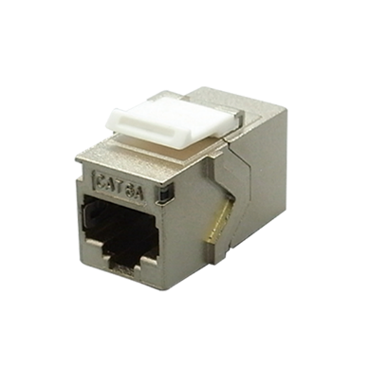

Female to female in-line coupler offer two types - cable extension type and panel mount type, compact housing and great performance. Panel mount type can be used with series I flush mount wall plates.

Features

Metal Housing for STP version: Zinc Alloy with Nickel plated

UL Listed

Option for cable extension type or panel mount type

Contacts are phosphor bronze plated with 50 micro inches hard gold

4PPoE compliant in accordance with IEEE802.bt Type 4

Ordering Information

|  |  |
| --- | --- |
| PART | Description |
| CP8DZ00A | RJ45 8P8C Cat.6A, STP In-line coupler, Panel mount, Zinc Alloy Housing, H.D. version, fits 0.5U panel |
| CP8DZXTA | RJ45 8P8C Cat.6A, STP In-line coupler, Extension Type, Zinc Alloy Housing |
| CP8EZ00A | RJ45 8P8C Cat.6A, STP In-line coupler, Panel mount, Right Angle Zinc Alloy Housing |
| CP80000A-XX | RJ45 8P8C Cat.6A, UTP In-line coupler, Panel mount type, H.D. version |